**Day-03 API Integration Report**

**API Integration Process:**

*Step 1: API Endpoint Setup*

API Endpoint: “[https://template-03-api.vercel.app/api/products”](https://template-03-api.vercel.app/api/products)

In the provided API the product data was given included fields : product name, price, category, description, inventory, image, color, status.

“Axios” (library) was used to fetch data from the API.

*Step 2: Fetch Data from API*

-The API call retrieves an array of product objects from the endpoint, ensuring proper data serialization (converting data into a format that can be stored ).

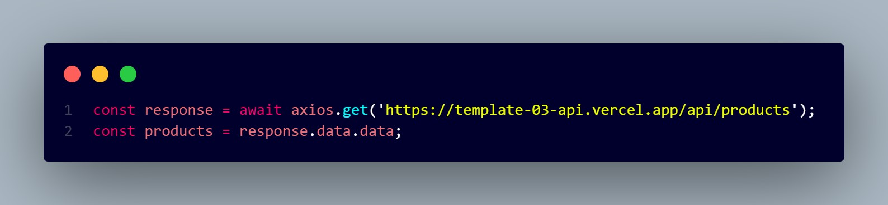

**Adjustments in schemas:**

Color, Status and Inventory fields updated, as I didn’t add them yesterday but today I updated the fields according to provided API.

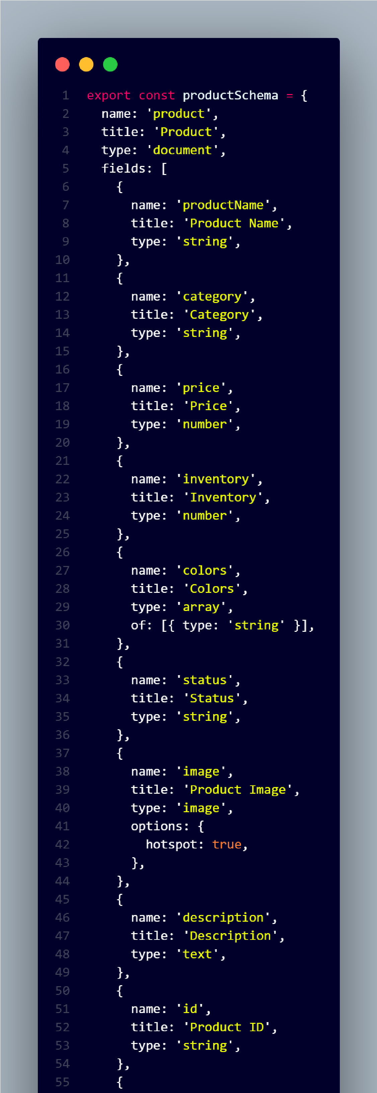

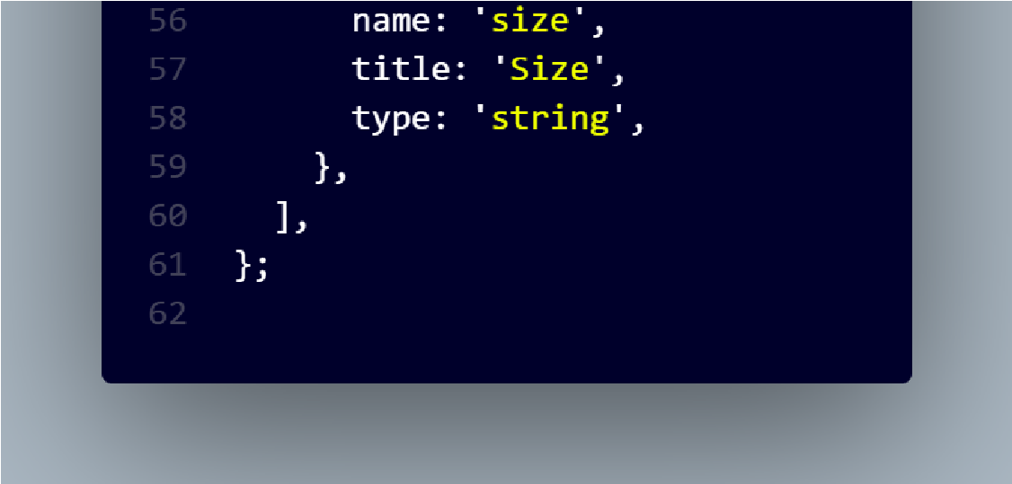

**Migration Steps:**

Installed required dependencies: `@sanity/client`, `axios` and `dotenv`.

Update `.env.local` file to store environmental variables.

Retrieved product data from API endpoint using **Axios**.

Downloaded images from API’s image field using **Axios**.

For uploading images.

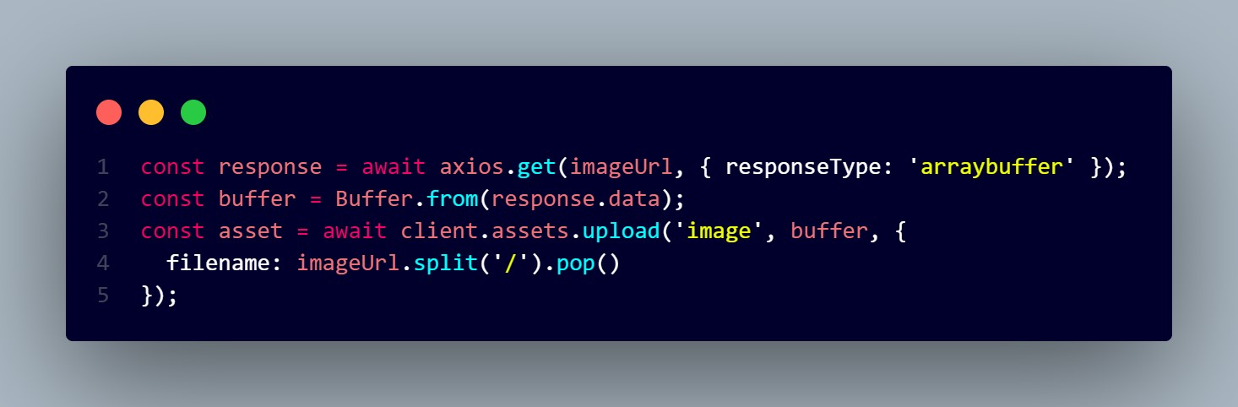

This code fetches an image from a given URL, converts it into a bu er, and uploads it to a storage client.

**Tools used:**

**Sanity Client** for interacting with Sanity CMS.

**Axios** for making HTTP requests to fetch API data and images. **Dotenv** to load environmental variables from ‘.env.local’.

**API calls:**

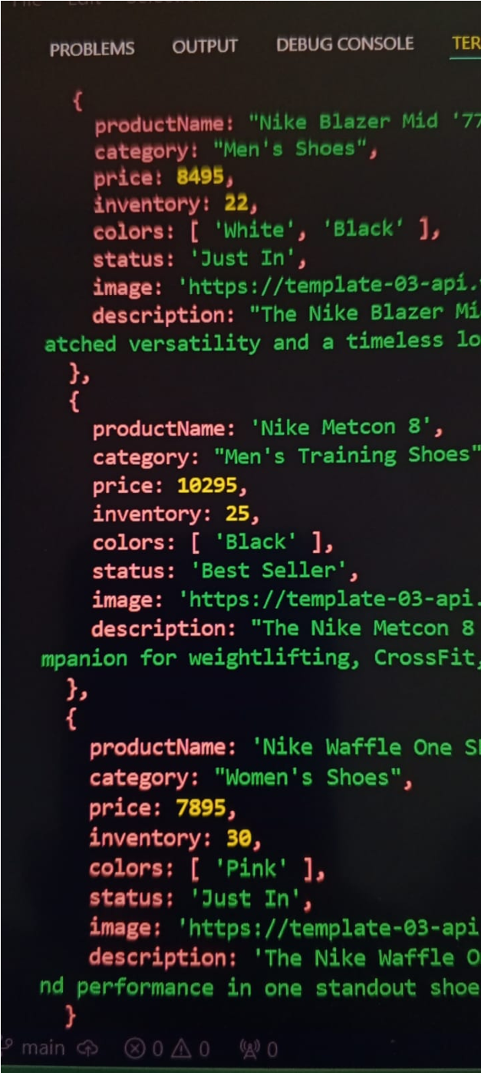

**Data Displayed in Front-end.**

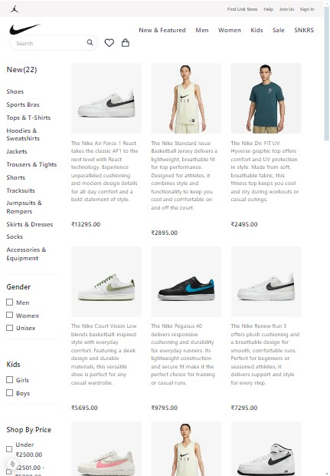

**Sanity CMS Fields:**

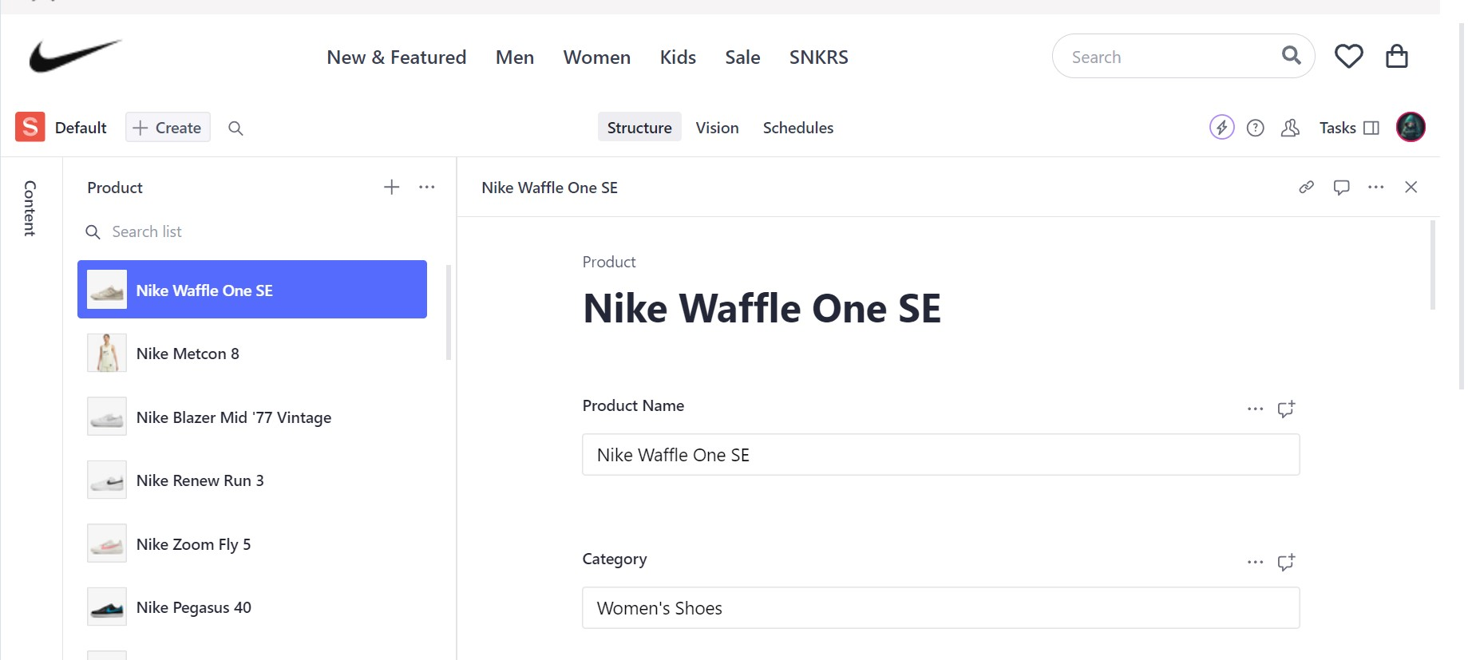

**Code Snippets:**

*API Integration:*



*Migration Script:*

